Rental listings
Please note that all rental advertisements listed are advertised via the internet.

ATCAA encourages you to check with the property management companies to verify that these advertisements are correct.
We also encourage you to contact your county’s housing verification/ Assessor’s office (Tuolumne County 209-533-5535) to verify ownership of a property before pursuing any rental opportunities. Identity theft can come from sharing credit reports application information that has bday, ssi number etc. Never mail cash for keys—scam
To Open Links put cursor on them press control and right click mouse.

Sober Living Houses
Second Chance House
Contact Tina (209) 472-9615

Fair Market rent, Available Rentals
Make sure the person renting is the landlord and not a tenant or scammer (This is subletting and not legal without a lease with the owner or property management company.) You can call our county accessor’s office with the address and verify if the said landlord does own the dwelling 209-533-5628. Never, ever send money to anyone in the hopes of getting keys.
SonoraVille Rents
MONO VILLAGE APARTMENTS
Located in East Sonora
Peaceful community setting, pool, on-site laundry
No application fees!
Call 209-532-6520.

https://www.eaglemgmnt.com/ Must contact to view their properties they are not listing them.

Quail Hollow One Apartments 20230 Grouse Way Sonora, CA 95370 In God We Trust Starting at.... 1-Bdrm. $1365-$1398 2-Bdrms. $1420-$1485 Amenities: Clubhouse, pool, and weight room, plus expanded basic cable included in rent! Call 209-533-1310 quailhollowone.com Furnished units available.
The new rentals are highlighted. To access the rental link from a computer: press Ctrl+ Click

RV Rental Space:

Details for RV SPACES FOR RENT $600-$650 p
Updated Jul 12, 2024
RV SPACES FOR RENT $600-$650 per month. 209-568-7009

RV Space 525.00
MyMotherLode.com Classified Ads - Real Estate Rental &amp;amp; Sale Vacation &amp;amp; Resort Rentals
Allison Way &amp;amp; Hwy 108&lt;br /&gt;Rent or Purchase Price: RV SPACE for rent.— $525.00 p/mo&lt;br /&gt;&lt;br /&gt;Large, private RV space for rent, great location, includes water, garbage and sewer. You pay electric and propane. Has nice office type shed, &lt;br /&gt;$525.00 per month&lt;br /&gt;No Pets&lt;br /&gt;Yes
classifieds.mymotherlode.com


55 plus RV Park space rent must have own RV
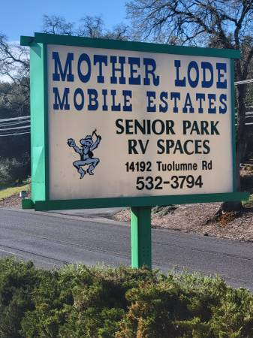 | McMotherlode Estates - apts/housing for rent - apartment rent - craigslist  Long Term RV sites available in a 55 plus park. Rent is $746.00 a month includes water, sewer and trash. On site laundry facility. Close to shopping and grocery store. You must have your own RV for...  goldcountry.craigslist.org

ROOMS Available:
1 bedroom shared housing 850.00
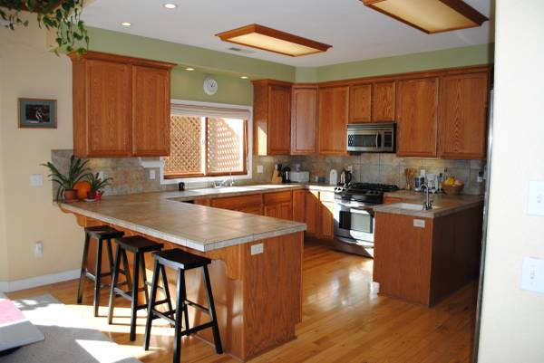 | Seeking a Mature Housemate — M or F - rooms & shares - apartment room roommate share rent - craigslist  Small, furnished bedroom, carpeted, with a large closet. Share bathroom with one retired gentleman. The weather here at 3,200' elevation is mild and usually sunny... above the fog and below the...  goldcountry.craigslist.org


Bedroom in a 3 bedroom House 500 a month
Room for rent - rooms & shares - apartment room roommate share rent - craigslist
Nice room for rent in Sonora. Phoenix Lake Country Club Estates. No smoking indoors. Seating areas outside on decks. No illegal drugs. 420 ok outside only. Pets ok.
goldcountry.craigslist.org


Shared house 1 bedroom please see details
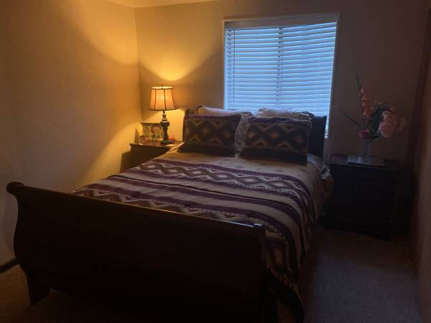 | Quite upscale room in Jamestown Area ! - rooms & shares - apartment room roommate share rent - craigslist  Beautiful room and home in the historic Jamestown Ca . private bath and shower that’s all yours as well as all modern amenities in this home in a private community with all the amenities inside....  goldcountry.craigslist.org

A room share bathroom, living room, kitchen 1/2 electricity and heat 650.00 month
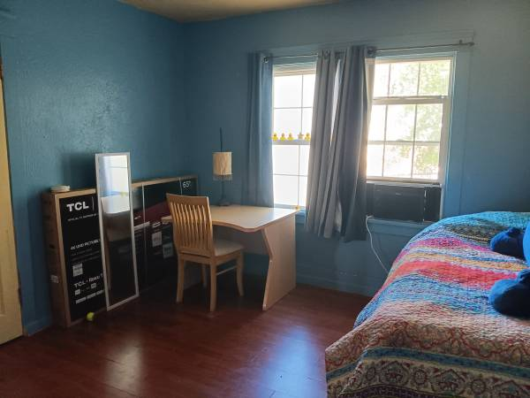 | Room for rent - rooms & shares - apartment room roommate share rent - craigslist  Room for rent in Sonora Ca, $650 month, split electric and heat, shared bath, living room, laundry &amp; kitchen access. WiFi, close to high school and downtown. Off-street parking. Room is $650 a...  goldcountry.craigslist.org

STUDIOS and ONE BEDROOMS Available:
Studio Water sewer 1150.00
Century 21 Wildwood Property Management
Let Century 21 Wildwood Properties, Inc. be your only Tuolumne County Property Management Company. You can trust us to provide you with excellent property management services for anything to do with Sonora and Twain Harte homes for rent.
century21wildwoodrentals.managebuilding.com

Studio ideal for single person nonsmoker no pets 1,100.00 month
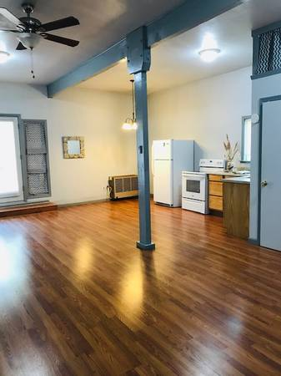 | Studio apt - apts/housing for rent - apartment rent - craigslist  Very nice Studio apt. spacious main room with kitchenette, remodeled shower, new electric stove, newly painted interior. Water, garbage, internet and electricity included in rent.. Propane fuel for...  goldcountry.craigslist.org


1 bedroom House
Large 1 bd house - apts/housing for rent - apartment rent - craigslist
Very cute large 1 bedroom house, close to Sonora and Columbia. Washer/dryer hookups, carport $1275.00 per month call for more details.
goldcountry.craigslist.org

Studio 950.00 Includes Sewer and Trash
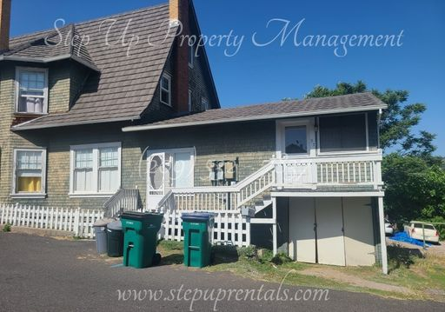 | 57 S. Norlin St., Sonora, CA 95370  Located in Historic Downtown you’ll find all of what Sonora has to offer within your sights! Renovations have been made to this attached studio that meets today’s standards of comfort including newly installed flooring, fresh paint, electric mini-split AC/heating unit, and blinds. To further highlight the classic décor of this home, you’ll find a couple vintage charms that adorn this quaint space! This all electric home has a compact electric stove with overhead vent which gets the job done while only taking up minimal space. The small, yet functional bathroom offers a roomy stand up shower! Downtown parking will be scarce but here you’ll have one designated off street parking spot included! Within walking distance to the Farmers Market, Bars, Restaurants, Banks, Grocery Shopping, Fairgrounds, Hiking trails, Parks, and of course, a prime location for the parade routes! Sewer and trash services included! Sorry No Pets Photos displayed for this property are deemed reliable, but are not a guaranteed rep  accessasset.appfolio.com

https://goldcountry.craigslist.org/apa/d/twain-harte-studio-music-studio-cottage/7758585272.html
STUDIO/MUSIC STUDIO/COTTAGE FOR RENT - apts/housing for rent - apartment rent - craigslist
STUDIO/COTTAGE FOR RENT. Date available : AVAILABLE NOW (posting for a friend/owner, that does not have a computer) Owner lives on property, and can not assist you with some of his requests. (this...
goldcountry.craigslist.org

Studio 875 water sewer included showing 6/24/24
39 Green Street, Sonora, CA 95370
Wonderful LARGE downtown studio. Just around the corner from Courthouse Park, this studio is in a fabulous location to be right in Sonora. Newer carpet and water heater, great closet space, lots of kitchen cabinets and lighting, Bathroom has a shower but no washer/dryer hookups. Rent includes water and sewer. Street Parking. 12 month lease. Absolutely NO Smoking or Pets!
www.motherlodepropertymgmt.com

https://century21wildwoodrentals.managebuilding.com/Resident/public/rentals/277690
1150.00 Includes water and sewer

1 bedroom in Riverbank 1095 a month
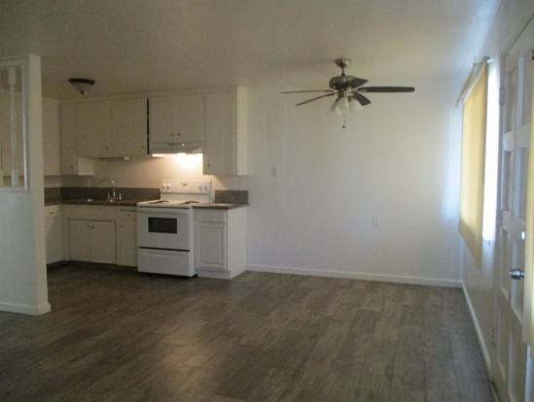 | Coming mid May- 1bed/1bath apt in Riverbank – Frontier Property Management | Property Management & Sales in Tuolumne County, Calaveras County  www.frontierone.com
2 BEDROOMS Available:
2 bedroom 1250.00
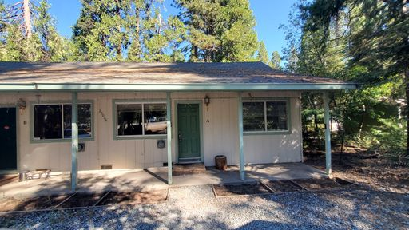 | 25026 Highway 108 - A, Mi Wuk Village, CA 95346  accessasset.appfolio.com


2 bedroom 1 bath with pool access 1595.00
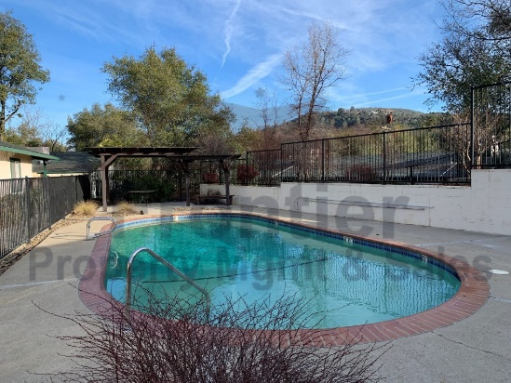 | 2 bedroom/1 bath apartment with pool in Sonora-Available mid July – Frontier Property Management | Property Management & Sales in Tuolumne County, Calaveras County  www.frontierone.com


2 bedroom Early July- please eligibility
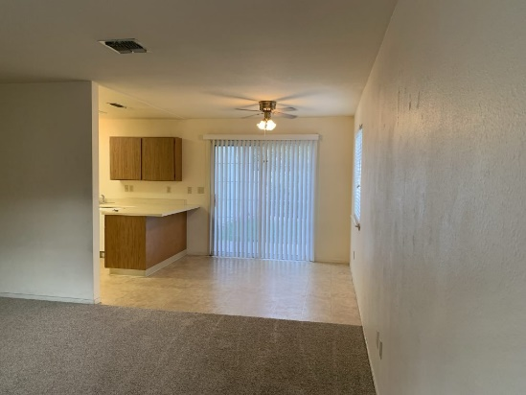 | Coming early July-2 bedroom/1 1/2 bath townhome in Sonora 20127 Shannon Dr. #D – Frontier Property Management | Property Management & Sales in Tuolumne County, Calaveras County  www.frontierone.com

Available June 28 2 bedroom1 bath 1495.00
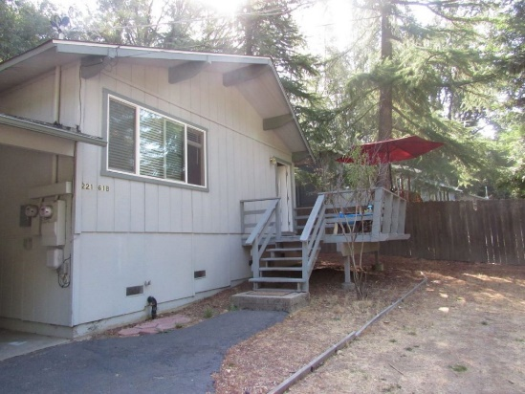 | 22161 Crystal Falls Dr Unit B. , Sonora – Frontier Property Management | Property Management & Sales in Tuolumne County, Calaveras County  www.frontierone.com

3 BEDROOMS Available:

Details for House for Rent $1,500 -
Jul 12, 2024 EAST SONORA - House for rent $1,500 - you pay util 3 bd / 2 bath / gar sp Call (509) 844-8778 Union Democrat

3 bedroom 1 bath 1650.00
Century 21 Wildwood Property Management
Let Century 21 Wildwood Properties, Inc. be your only Tuolumne County Property Management Company. You can trust us to provide you with excellent property management services for anything to do with Sonora and Twain Harte homes for rent.
century21wildwoodrentals.managebuilding.com


Mid July 3 bedroom 2 bath $1495.00
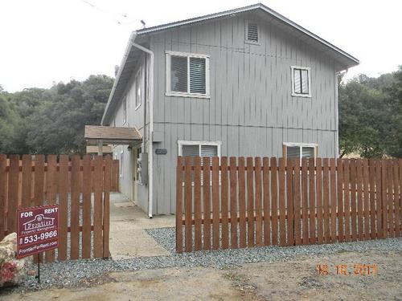 | 10702 Tenth Ave Unit B, Jamestown 3/2-coming mid July – Frontier Property Management | Property Management & Sales in Tuolumne County, Calaveras County  www.frontierone.com


3 bedroom Sonora hills 1375.00 only those really interested please
Rento casa en Sonora hills - apts/housing for rent - apartment rent - craigslist
Rento casa para pareja. 3 cuartos 1 baño. $1375 renta más depósito Llamar solo personas realmente interesadas. Solo llamadas. NO EMAILS.
goldcountry.craigslist.org

PLEASE BE AWARE OF SCAMS! THIS IS AN EXAMPLE OF ONE OUT THERE

I was contacted this weekend by a gentleman who tried to Scam Me with Rental & Identity Fraud. Please be aware of Walter D. Frieze, he DOES NOT own the home in Columbia & he can’t talk on the phone due to being deaf. Tried to get me to put a down payment TODAY in the form of a Gift Card, plus another $50 to FedEx the Keys to me. I did my Due Diligence and found out the home is actually active for sale on the market. Contacted the agent who also contacted the owners and are reporting it to Law Enforcement! 🏡

Tuolumne County Sheriff
May 15 at 10:17 AM
Have you heard of the Rental Scam?
Rental scams have been around for some time, and we want to warn our residents. Rental scammers try to get money from a prospective tenant for a property which in most cases are real, by listing the rental onto media sites such as Facebook and Craigslist. The scammer might lead all prospects to believe they're getting the rental and collect fees and security deposits upfront. The scammer may pose as the property manager for the home owner, when in fact the owner is unaware of what is occurring. Once the prospects realize they've been scammed, the scammer has usually vanished with their money.
*Tips to help prevent being scammed. *
-Always be aware of requests to send cash or money orders. Be wary of any person who attempts to get you to sign a lease or hand over a substantial amount of money on the spot.
-Look at property with the Realtor or Property Management Company and ask for identification. Sign a lease in person after you view the property and request copies of everything you sign. Never pay a security deposit or payments with cash. This makes it harder to track.
-Conduct basic research. Google the address of the apartment or home and also the landlord's name and the name of the management company. Look for red flags and inconsistencies.
-If the deal seems too good to be true, it probably is. Prevention is always far better than trying to recover from fraud after-the-fact.
1. If you fall victim to a rental scam make a report with law enforcement and give them as much information as possible.
2. Contact the publisher/ company behind the ad and let them know what happened.
3. If you become the victim of a rental scam in the United States consider reporting it to the federal trade commission (FTC), federal consumer protection agency. 1-877-382-4357 (1-877-FTC-HELP).
4. Share your story with friends, family and as many people as you can to help prevent others from falling victim to the same.
Links to search for employment:

The Essential Job Search Guide
Check out this helpful information!

Training while getting paid!
Positions at Columbia College
Check it out on the Columbia College website or
Visit Mother Lode Job Training and inquire.

My Motherlode Job listings
The Union Democrat Job listings
Craig’s List Gold Country Job listings
ATCAA JOB Openings
Mother Lode Job Training: https://www.mljt.org/
Employment Development Department https://edd.ca.gov/
Indeed: https://www.indeed.com/
Zip Recruiter: https://www.ziprecruiter.com/
Monster: https://www.monster.com/
Simply Hired: https://www.simplyhired.com/
Career Builder: https://www.careerbuilder.com/
Tuolumne County: https://www.tuolumnecounty.ca.gov/923/Current-Employment-Opportunities
State of California: https://www.calcareers.ca.gov/
Federal: https://www.usajobs.gov/
Adventist Health: https://www.adventisthealth.org/sonora/about-us/careers/
Walmart: https://careers.walmart.com/
Black Oak Casino: https://www.blackoakcasino.com/careers/?gclid=EAIaIQobChMIgrS22YnQgAMV0hmtBh3grwYuEAAYASAAEgKohPD_BwE
Chicken Ranch Casino: https://chickenranchcasino.com/employment/
Call Tuolumne County Transit to set up a Dial-A-Ride!

Eligibility
Weekdays:
Persons with disabilities with or without ADA Certification and persons who are 60 years of age and older.
Saturdays:
General Public (on a space available basis)

Service Hours
Weekdays:
6:25am - 7:25pm
Saturdays:
11:00am - 4:00pm

Pick-up Windows
When you call for service, you are given a 30-minute period as an approximate pick-up time. Please be ready 15 minutes prior to your stated travel time and up to 15 minutes after, this constitutes the 30-minute window. While we make every effort to deliver you to your destination quickly, you may share the bus with other riders who are going in the same general direction.

Reservations
To make reservations, or for more information regarding the Dial-A-Ride Service, please call the Transit Office at 532-0404. Have the following information ready:

- your name
- where you want to be picked up
- where you want to go
- when you want to arrive
- the number of people in your party
- if a wheelchair lift is needed

Reservations should be made at least one day in advance. Same day service may be accommodated on a space available basis only.

